 | General Data Protection Regulations Statement  There is a law called General Data Protection Regulation or GDPR. This law has rules that make sure that any information about you is kept safe. Your Voice Counts will make sure we follow these rules.
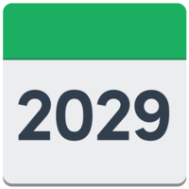     | The personal information on this form will be held safely and will be used for helping you with the things you have asked us to.  We will keep the information for 6 years.  We may also share anonymised information about you with the NHS. This means we take your name off so they can’t tell the information is about you. They use this for research and to make their services better. You can find out more about this on these websites:  Mental Health Services Data Set  How your information is used and kept safe
  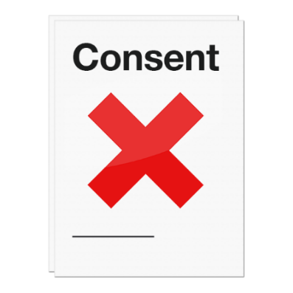   | You have the right to ask for a copy of the information we hold about you.  You can ask for information about you to be changed or removed from the records we keep if you think we don’t need your information anymore.  You have the right to change your mind and tell us that you don’t agree to the things in this form anymore. This is called ‘withdrawing consent’. You can do this by getting in touch with Your Voice Counts.  You can also contact Your Voice Counts if you have any questions about this form or what we do with your personal information
  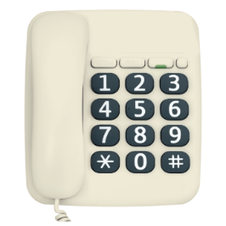 | Contact details  Jenny Rohde (Head of Operations) jenny.rohde@yvc.org.uk  0191 478 6472
 | Complaints  You have the right to make a complaint against Your Voice Counts if you are not happy with how your personal information has been used.  If you want to make a complaint you can contact the Information Commissioner’s Office. This is their website:  https://ico.org.uk/concerns  You can also ring this number:  0303 123 1113

Communities First Contact Form
Date


Referrer name and organisation
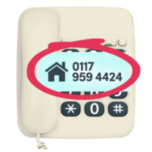
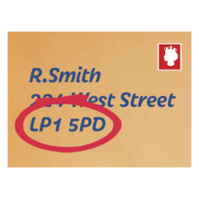
Referrer contact details
Name of person
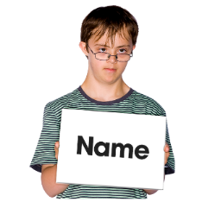

Date of birth
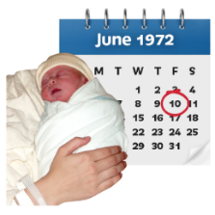

What is your Address and postcode?
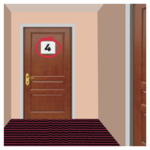
What is your phone number?
What is your email address?

What type of home do you live in?  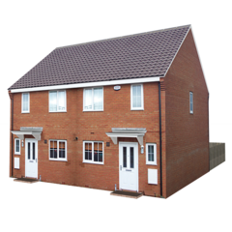  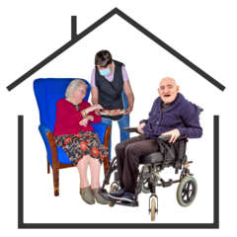 | I own my own home
 | On my own and I pay rent
 | With my family or unpaid carers
 | On my own with paid carers visiting to give me support
 | Sheltered accommodation
 | In a residential home
 | In independent supported living
 | Somewhere else
Which Doctor Surgery do you go to?
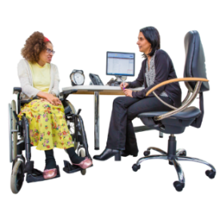

What is your NHS number?

Do you have a Learning Disability or Autism?  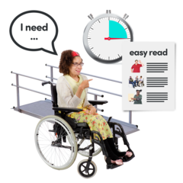 | Learning Disability | Autism |  |  | Learning Disability and Autism |  |  | Don’t Know
What is your gender identity?   | Male
 | Female
 | Intersex
 | Non-binary
 | Prefer not to say
 | If you prefer to use your own term, please say here:
 | Is the gender you identify with the same as your sex registered at birth? |  | Yes
 |  |  | No
 |  |  | Prefer not to say
What is your sexual orientation?      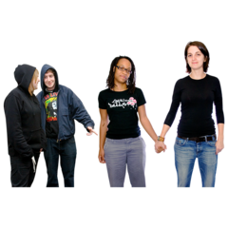 | Heterosexual
 | Gay
 | Lesbian
 | Bisexual
 | Prefer not to say
 | If you prefer to use your own term, please say here:
What is your ethnic origin?   | White  Includes British, Northern Irish, Irish, Gypsy, Irish Traveller, Roma or any other White background.
Mixed and Multiple Ethnic Groups
Includes White and Black Caribbean, White and Black African, White and Asian or any other Mixed or Multiple background.
Asian or Asian British
Includes Indian, Pakistani, Bangladeshi, Chinese or any other Asian background.
Black, Black British, Caribbean or African
Includes Black British, Caribbean, African or any other Black background.
Other ethnic Group
Includes Arab or any other ethnic group.
    Do you have a religion or a religious belief?     | No religion or belief
 | Buddhist
 | Christian
 | Hindu
 | Jewish
 | Muslim
 | Sikh
 | Prefer not to say
 | If other religion please say here:

Is there anything we need to know about you or what is happening in your life to keep you and other people safe?


How should we get in touch with you e.g. phone/ WhatsApp and tell us if you have any communication needs e.g. Makaton
We offer lots of support. Please tell us what you need from Your Voice Counts.  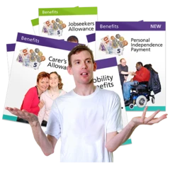  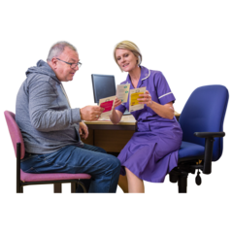    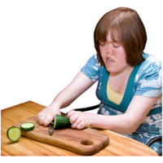 | Cooking skills
 | Money, bills or benefits
 | Meeting people and making friends
 | Mental or physical health support
 | Phone or computer skills
 | Joining our groups or training
 | Young Person’s Group
 | Other e.g. volunteering
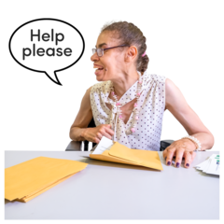
Tell us more about what you need.

Please send the completed form to: yvc.uk@nhs.net

